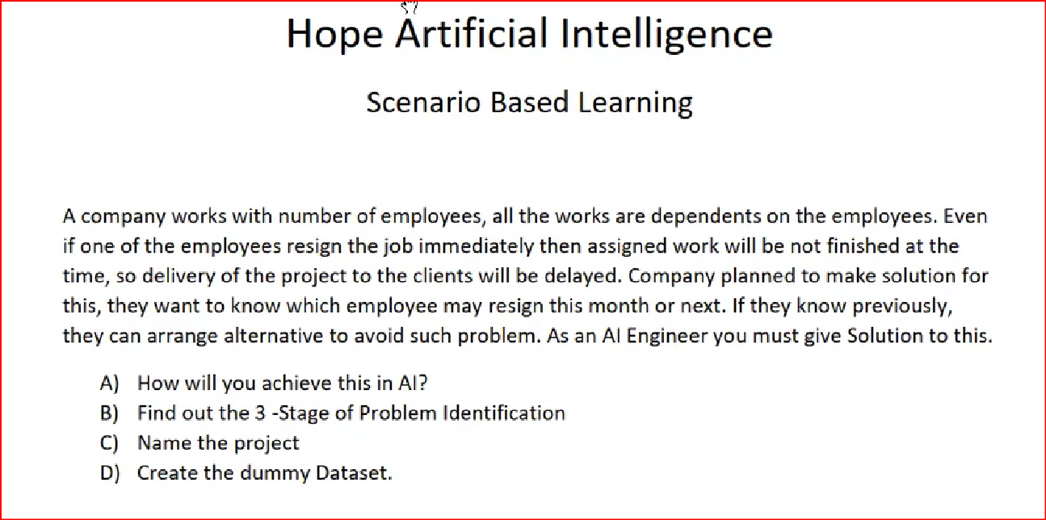

For example:

A company has = 1500 employees

Work would get delayed if even one employee resigns immediately.

To avoid delays, company wants to know which employee resigns this month or next.

1. How will you achieve this in AI?

This can be achieved in Machine Learning model through **prediction**.

1. Find out 3-stage of problem identification.

Machine Learning.

Supervised.

Classification.

1. Name the project.

Team heads up about an employee resign.

1. Create the dummy dataset.

Attached below.

